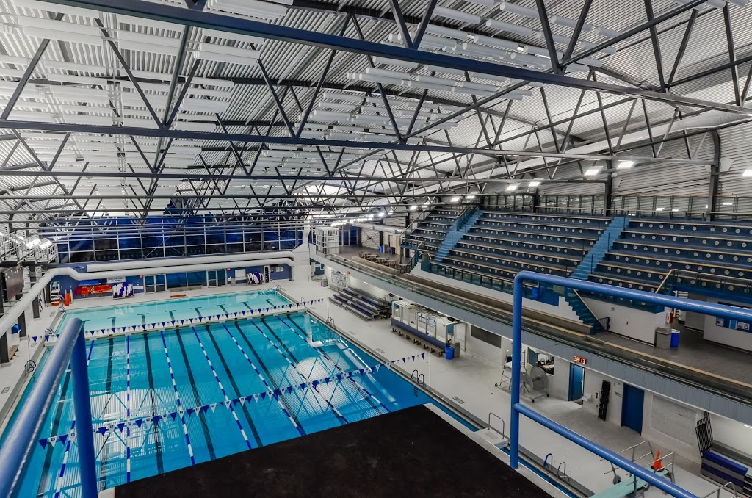



LAC - LONG COURSE
PENTATHLON

MEET PACKAGE

Sunday, April 9, 2017
CANADA GAMES AQUATIC CENTRE – LONDON, ONTARIO

7th Annual
LAC - Long Course Pentathlon
DATE(S): | Sunday, April 9, 2017
HOSTED BY: | London Aquatic Club
LOCATION: | Canada Games Aquatic Centre  1045 Wonderland Road North  London, Ontario N6G 2Y9 (between Gainsborough and Lawson Road)
FACILITY: | Eight lane, 50 meter indoor tank, with “Keifer” type lane markers; Daktronics 64101-H8 8 lane swimming scoreboard at both ends of pool with Omega Swiss Timing Quantum Timing System.
PURPOSE: | Long Course Invitational
MEET PACKAGE: | The only meet package which will be considered as valid must be the most current version found on www.swimming.ca
MEET MANAGER: | Michael Mohammed | E-mail: michaelmlacmm@gmail.com
COMPETITION COORDINATOR: | Bonnie Marceau – Level V | Phone: 519-633-6368  E-mail: brmarceau@rogers.com
MINOR OFFICIALS: | Mike Joudrey | E-mail: mikejoudrey@hivaidsconnection.ca
DESCRIPTION: | Seeding for all swims will be slowest to fastest by submitted entry times. This meet will be senior seeded by gender. All events are Timed Finals.  This invitational meet will be 2 sessions limited to approx. 180 swimmers per session.  Morning: 13 & Over; Afternoon: 12 & Under  Should over subscription occur, those clubs affected will be notified ASAP.
COMPETITION RULES: | Sanctioned by Swim Ontario  All current Swimming/Natation Canada (SNC) rules will be followed.  Please note that Swimming Canada Competition Warm-Up Safety Procedures will be in effect. Swimmers witnessed by a Safety Marshal diving or entering the water in a dangerous fashion will be removed without warning from their first individual event following the warm-up period in which the violation occurred. The full details can be viewed HERE.  Only FINA approved swimwear is allowed in competition as per GR 5. The full details can be viewed HERE.
AGE UP DATE: | Age determined as of first day of meet, Sunday, April 9, 2017.
ELIGIBILITY: | All athletes must be registered as Competitive Swimmers with SNC, or any other amateur swimming organization recognized by FINA. A valid SNC registration number is required for all Canadian swimmers, and entries without a SNC registration number will be declined entry.
QUALIFYING/  DE-QUALIFYING TIMES: | There are no qualifying or de-qualifying times.

ENTRY FEES: |  | $10.00 per swimmer per individual event.  (includes HST – London Aquatic Club GST # R103378279)
PAYMENT: |  | Please submit one cheque for all club swimmers with your entries.  Payable to: London Aquatic Club
ENTRIES: |  | Entries will be at the discretion of the Meet Manager.  All entries must be in Hy-tek format and be submitted through the SNC online entries system at: www.swimming.ca.  Meet Management will not accept entries directly via any other means.  Please include appropriate Long Course (in meters) entry times (estimate if necessary – “NT” entries WILL NOT be accepted).
ENTRY DEADLINE: |  | Entry Deadline: Monday, March 27, 2017 by midnight.  You will be sent confirmation of receipt of your entries.  Please ensure that you check these entries and immediately contact the Meet Manager with any problems.
DECK ENTRIES: |  | Deck entries may be accepted (as Exhibition Swims) to fill empty lanes or scratched lanes, but will not be eligible for awards or prizes in those events.
DECK ENTRY FEES: |  | $12.00 per swimmer per individual event.  Payable at the time of the request.  (includes HST – London Aquatic Club GST # R103378279)
SCRATCH RULE: |  | Coaches please bring in your scratches 30 minutes prior to the start of the meet. There will be no penalty for a missed swim.
CONVERSION: |  | Any Short Course times submitted will be converted into Long Course times using MM6 default conversion factor.
AGE CLASSIFICIATIONS: |  | Male and female:  Individual: 8 & Under; 9; 10; 11; 12; 13; 14; 15; 16; 17 & Over.
PARA: |  | PARA swimmers will be officiated under IPC Swimming Rules.
MANAGEMENT ITEMS: |  | Meet Management reserves the right to double end due to time restraints, with the longer end starting in the deep end. Warm-up and start times may be changed. Notification will be made 7 days prior to the meet.  Meet Management reserves the right to limit the number of entries and the number of swimmers in any event.  Timed Final Events:  All events will be swum slowest to fastest by submitted entry times.  Sprint lanes for the last 20 minutes of warm-ups. Lanes 1 and 8 will be used for Sprinting and are designated as diving lanes. After the dive the swimmer must leave the lane and return to the starting end. PARA and Backstroke start lanes may also be designated, will be announced, and then will be controlled by the Safety Marshalls.  Meet officials will provide a safe environment and an organized competition. We are not responsible for the supervision of the athletes during the competition or during session breaks.
CANCELLATIONS: |  | In the event of unforeseen circumstances beyond the control of the City of London or London Aquatic Club, (for example but not limited to; weather interruptions or facility malfunctions) that force the cancellation of all or part of the meet, a partial refund may be granted at the discretion of the Meet Manager.
COACH'S REGISTRATION: | Meet Management will cross-reference the list of coaches in attendance at this competition with the Swim Ontario Compliancy lists. If a coach is not on this list, Meet Management is obligated to enforce the SNC policy and not permit that coach on the deck. Meet Management will forward to Swim Ontario a list of coaches who have been found to be in non-compliance.
TIME SPLITS: | The procedure for obtaining an 'Official Split' now requires that coaches make the request to the session Referee or Meet Management on a time card (provided by the Meet Office) prior to the race. The split for the lead-off leg in relays will still be regarded as an official split and therefore no request by coaches is needed for relays. However, in the new 'mixed gender' relays, lead-off times/splits are not considered “official splits' as per international practice.  Official Splits: Meet Management requires that any coach wishing to rely on a time achieved by the swimmer for an interval shorter than the total distance of the event shall so advise the Referee prior to the commencement of the session (or event) in question. Please note that the coach must provide 3 timers to complete this official split.
SCORING: | The meet will be scored as follows:  Individual events well be scored from 1st - 8th place on a scale of 9 - 7 - 6 - 5 - 4 - 3 - 2 - 1.
AWARDS: | By age classification.  Individual:  - 13 & Over - ribbons for 1st, 2nd, 3rd  - 12 & Under - ribbons for 1st, 2nd, 3rd  High Point Trophies:  - Scores will be accumulated and a trophy for male and female will be awarded to the swimmer with the highest score in each of the age classifications:  - To be eligible a swimmer must swim all five events in the Pentathlon without any disqualifications.  - In the event of a tie, the winner of the 200 IM will be declared the overall winner.
MEET RESULTS: | The meet will run on Hy-Tek Meet Manager. Results will be posted on the LAC website www.londonaquaticclub.ca as quickly as possible and uploaded to www.swimming.ca within 48 hours of the completion of the meet.  Unofficial results will also be posted to Meet Mobile following each event.
RECORDING OF THE MEET: | Only individuals who have made application and received authorization, in advance, to record the event, in any manner, in any medium or context now known or hereafter developed, shall be granted access and permission to do so. Please contact Meet Manager for application and authorization.  Photographers must obtain authorization from Meet Management before the start of the meet to obtain access to the deck.
SAFETY AND LIABILITY: | Only participating swimmers, officials, certified registered coaches, and authorized people are allowed on deck.
FOREIGN COMPETITORS: | All swimmers and coaches must be duly registered and residents of the governing body for which they are competing. All swimmers and coaches must be in good standing with their respective governing swim body.  All swimmers and coaches must have primary residence within the province /state or country for which they claim registration. Proof of residency may be green card, student ID, driver’s license, college residence or other document as deemed acceptable by Swim Ontario and shall be submitted with the Proof of Residence and Registration Status form to Swim Ontario no later than 7 days prior to start of competition.

MIXED GENDER: | Notwithstanding Rule SW 10.1 adopted by the Technical Swimming Committee of Swimming/Natation Canada, Swim Ontario will consider requests for sanction for meets that provide for mixed gender swimming in the following circumstances:  The host seeks an exemption from the requirement to swim events in gender separated events, on the following basis:  Due to facility or time limitations, swimming separated by gender would not permit all swims to be completed while offering reasonable opportunities to swim for all participants, and in particular on an equitable basis for swimmers of each gender.  Mixed gender swims may also be permitted when, due to a missed swim, it is necessary for a Referee to seed a swimmer in a heat of the same or shorter distance, for competitors of the opposite gender, on an exception basis.  In spite of this rule, any swimmer who achieves a record time at any level (regional, provincial, national etc, whether age group or open) will not be recognized for that record unless the coach has advised the Referee prior to the start of the session that there is a possibility of the record being broken, and the Referee ensures that the swimmer competes with competitors of the same gender for his/her heat.  In the event that mixed gender swims are permitted pursuant to this policy, the results must still be posted separately by the gender of swimmers.
DURING THE MEET: | Parking & Accommodations:  Parking and accommodation options will be posted on the LAC website – LAC Hosted Meet – Pentathlon. ( http://www.londonaquaticclub.ca )  Concession:  A snack bar will be open throughout the meet.

SCHEDULE OF EVENTS:

Session 1
Sunday Morning, April 9, 2017, Timed Finals
Warm-up ⇒ 7.00 a.m. Start ⇒ 8:00 a.m. Finish ⇒ Noon
Gender | Event |  | Timed Final | Gender
Women |  |  |  | Men
101 | 100 Fly | 13 & Over | Timed Final | 102
103 | 100 Back | 13 & Over | Timed Final | 104
105 | 100 Breast | 13 & Over | Timed Final | 106
107 | 100 Free | 13 & Over | Timed Final | 108
109 | 200 IM | 13 & Over | Timed Final | 110
Session 2
Sunday Afternoon, April 9, 2017, Timed Finals
Warm-up ⇒ Noon Start ⇒ 1:00 p.m. Finish ⇒ 5:00 p.m.
Gender | Event |  | Timed Final | Gender
Girls |  |  |  | Boys
201 | 100 Fly | 12 & Under | Timed Final | 202
203 | 100 Back | 12 & Under | Timed Final | 204
205 | 100 Breast | 12 & Under | Timed Final | 206
207 | 100 Free | 12 & Under | Timed Final | 208
209 | 200 IM | 12 & Under | Timed Final | 210
*** The above schedule is tentative. No session will be longer than 4.5 hours in length.
Appendix A

Canada Games Aquatic Centre

Event Procedure Policy For:
Meet Managers, Officials, Coaches, Athletes & Spectators
- The City Of London Aquatic Staff (and specifically the CGAC Deck Supervisor) will remain in control of the facility at all times during the event. Their decisions and instructions are to be complied with without argument by all participants, coaches and officials. In the event of an emergency, City staff will only transfer care of an individual to EMS personnel.
- No coach or official may permit a swimmer to enter the pool prior to the lifeguards being in place. No swimmer is to enter the pool without lifeguards in place.
- All participants must obey all pool rules as posted.
- No outside footwear may be worn on the pool deck by any participant, coach, official or any other person.
- No food of any kind is permitted on the pool deck, except for refreshments provided directly to officials.
- Coaches are responsible for the conduct of their team at all times in all areas of the facility.
- Participants / coaches are responsible for picking up their garbage and depositing it in waste containers; excessive garbage left on the pool deck will be billed as an additional staffing charge.
- Participants must be dry and wearing footwear on the upper level.
- Participants / coaches / officials must not leave belongings in front of access points, including but not limited to emergency exits, staff offices, first aid rooms, change rooms, etc.
- Parking is permitted in designated areas only; parking is not permitted on curbs or on grass areas surrounding the building. Signs will be posted indicating parking locations.
RZONE
Rzone is a program requiring all persons wishing to visit or use any City of London recreation facility, park, or program, to respect others and take responsibility in helping the City maintain a positive environment. The "R" in Rzone stands for Respect and Responsibility. Respect for yourself, Respect for others, and Responsibility for your actions. The Rzone program applies to all community organizations and individuals using City of London recreational facilities, parks, and programs.

Please review the information online at http://london.ca/rzone before attending this event.
Appendix B

City Of London By-Law

Single Use Disposable Water Bottles

According to the City of London by-laws, single use disposable standard water bottles can no longer be sold at events hosted at city-owned facilities.

We will continue with our Maximize Waste Diversion. Water coolers / city water taps will be available for water needs for our Athletes, Coaches, Officials, and Volunteers.

Please make sure that you bring a refillable water bottle with you to our meet.

